Wiha as one of the ambassadors for sustainability at FWI Special Show at the Cologne International Hardware Fair 2022

Hand tool manufacturer WIHA is pleased to be flying the flag for sustainability and e-mobility together with German tool manufacturers LUKAS-ERZETT, WEICON and WEZAG as part of the special show organised by the Fachverband Werkzeugindustrie e.V. (FWI) at the Cologne International Hardware Fair 2022. Together, the trade fair platform is to be used to present the international audience with key fields of action for the future issues surrounding sustainability from the perspective of the tool industry. In addition to this, successes that have already been achieved, opportunities for the sector and technological developments will also be highlighted. Focusing on the selected topics of CIRCULAR ECONOMY, SOCIAL SUSTAINABILITY, DECARBONISATION, SUSTAINABLE PROCESSES, and E-MOBILITY, the manufacturers will highlight different starting points for addressing their own responsibility towards society, the environment and natural resources.
Wilhelm Hahn, Wiha CEO, explains: "It is great that our participation in the FWI special show gives us the opportunity to promote the topic of sustainability in the tool industry as part of a strong alliance and to give it a tangible face. Standing up for sustainability jointly, pulling together, sharing knowledge, experience and tips - that's exactly what I see as the right way to achieve the best results."
With a view to its own examples of measures, successes, processes or even products in the individual sustainability areas, the Black Forest hand tool manufacturer is looking forward to an in-depth exchange with visitors during the four days of the trade fair. Following to the principle 'The most sustainable product is the one that provides maximum service life’, Wiha quality products stand for durability, robustness and versatility. Wiha also lives the CIRCULAR ECONOMY approach. This regenerative system of a circular economy takes a comprehensive view of both the use of resources, waste production, emissions and energy waste. From product development to recycling and disposal at the end of the product life cycle, all reduction and optimisation options are analysed and coordinated. For example, Wiha already conducts intensive research into resource-saving production technologies during the product conception phase. Voltage-proof VDE screwdriver blades, for example, are already manufactured 100% galvanic-free. As one of the first manufacturers in the industry, Wiha has been using the system of recycling/regranulation of injection moulding sprues during screwdriver production since 1998. By the end of 2022, the entire Wiha self-service range will have been converted to a sustainable carton packaging concept. As the initiator of the "Tool Recycling" campaign, Wilhelm Hahn is taking a leading role in finding a cross-industry model for how tools that can no longer be used can be collected from the market and returned to the manufacturer's material cycle.
As another aspect, Wiha highlights SOCIAL SUSTAINABILITY. From the further development and promotion of the employee workforce through specially developed training programmes and e-learning, the use of compliance guidelines along the entire supply chain or long-standing cooperation with regional educational and social institutions: Wiha values a comprehensive view of its corporate responsibility. In his book "Freiheit - Zukunft der Unternehmensführung" (Freedom - The Future of Corporate Management), Wiha CEO Wilhelm Hahn describes in detail the interrelationships, measures and sustainable strategic approaches that can serve as a guide for other companies.
In the course of DECARBONISATION, the focus is on CO2 and emissions reduction through energy-saving measures on the buildings, the completion of a pellet power plant or the conversion of the vehicle fleet to electric vehicles. As an example of SUSTAINABLE PROCESSES, Wiha will present, among other things, its digital solution for the free community 3D printing online platform www.tlbx3d.com relating to tools. In the E-MOBILITY area, Wiha will be showing its current product range of customised e-mobility tool assortments and workshop solutions. Visit Wiha on the topic of sustainability at the FWI special show at the Cologne International Hardware Fair in Hall 10.1 | Stand: D1/C2 from 25 - 28.09.2022. You will also find the Wiha trade fair stand with exciting product highlights from the world of hand tools and inspiring solutions for the specialist trade in Hall 10.1 | Stand F3/E4.

About Wiha
Wiha is one of the world's leading manufacturers of hand tools for professional use in trade and industry. Founded as a small family firm in 1939, Wiha is today a globally active company, still owner-operated by the Hahn family. The comprehensive range of Wiha solutions includes tool concepts, systems and sets, screwdrivers, torque tools, multitools, L-keys, bits, pliers, soft-faced hammers, electrical solutions and much more. In 2022, the company with headquarters in Schonach in the Black Forest received the honourable distinction of being one of the "TOP 100" most innovative companies in the German SME sector for the third time. In 2019, Wiha received the German Brand Award and the Red Dot Brand Award "Best of the Best” for its excellent brand work and development.

Company
Wiha Werkzeuge GmbH  Obertalstrasse 3 – 7  78136 Schonach  www.wiha.com | Contact person PR / media communication  Anne Jakubowski, Marketing Communication / PR  Tel.: 07722 959-209  Mobile phone: 0151/163 414 94  e-mail: anne.jakubowski@wiha.com

 | Wiha's CEO Wilhelm Hahn is looking forward to his company's participation in the FWI special show at the Cologne International Hardware Fair 2022. | 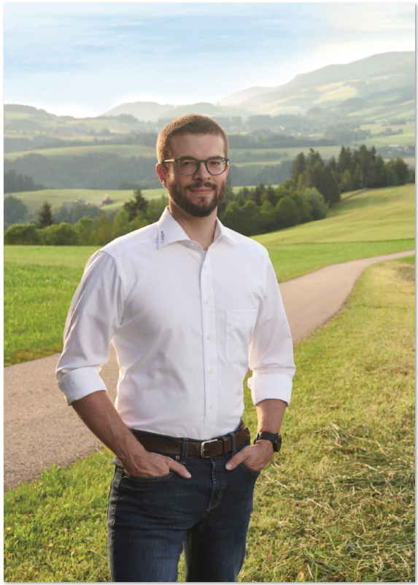
 | At Wiha, plastic waste during screwdriver production is recycled back into the manufacturing process to reduce resources and waste. | 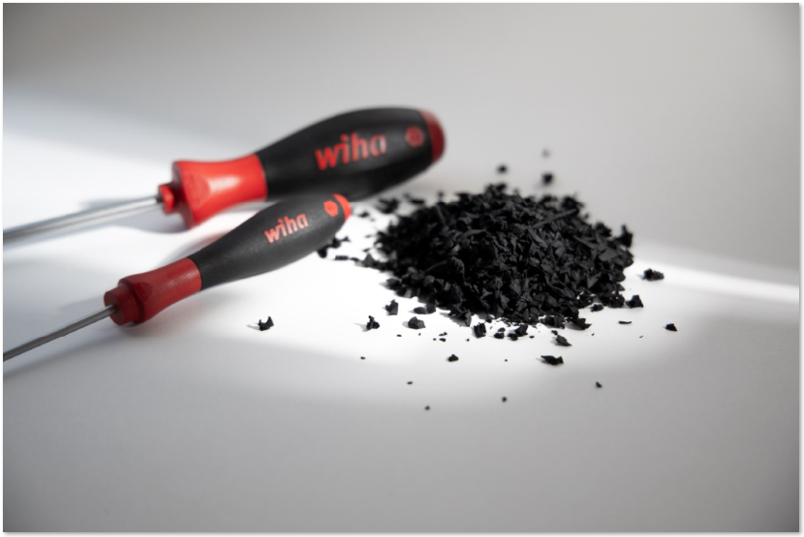
 | Wiha's sustainable packaging concept relies on environmentally friendly carton packaging. | 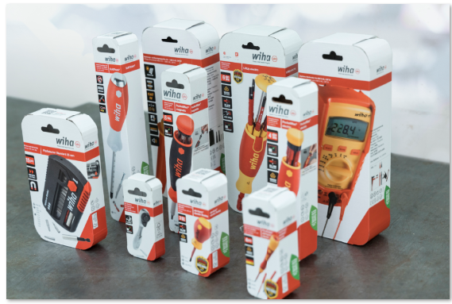
 | A pellet heating system will soon enable a significant CO2 reduction or the achievement of the manufacturer's Scope 2 targets. | 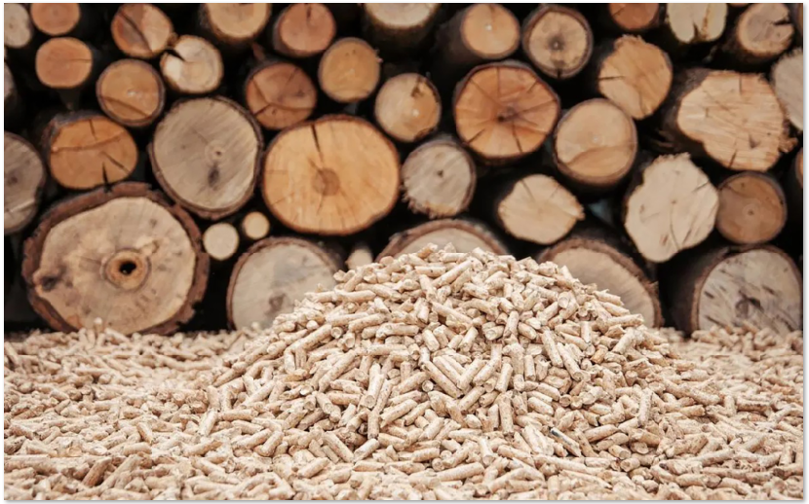
High-resolution images can be found here (as download zip-file) in the press section www.wiha.com/de/newsroom under the corresponding press release (from 25/09/2022).

